COSHH ASSESSMENT NCS/FM/070 Issue005/Jul09

Ref: COSHH 07

Assessed by: Matt Traynor Position: Managing Director

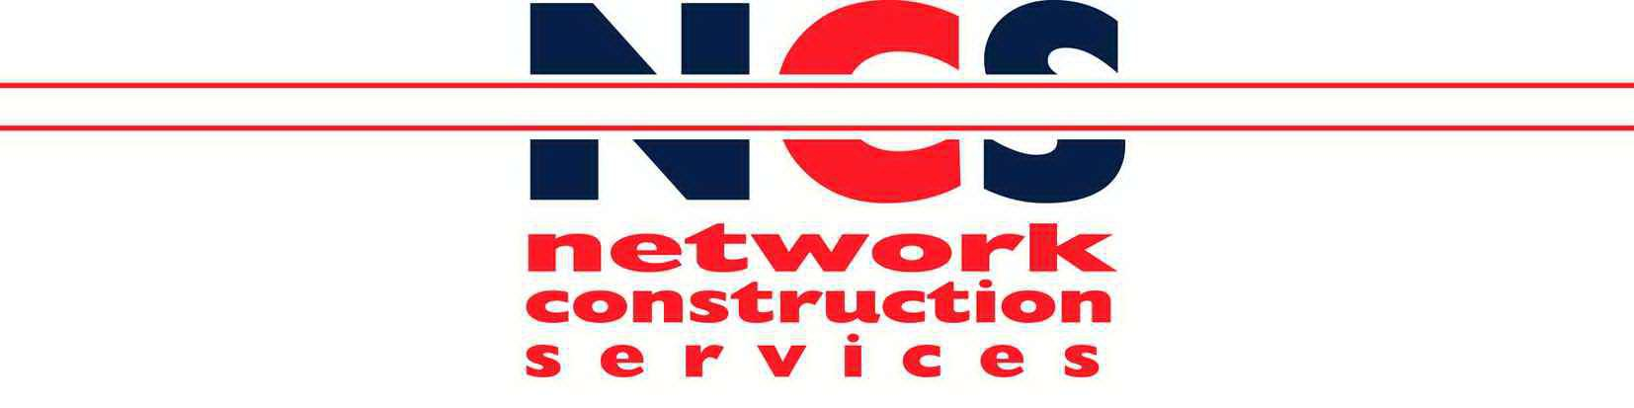Date: January 2022

Reviewed by: Matt Traynor
Position: Managing Director
Date: January 2022
Issue: 008/Jan 22

Trade name / Supplier: Telephone number:

Contact:

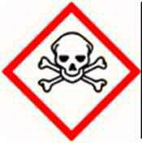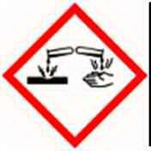Toxic Corrosive

Product type:

Lead straps - on detonators

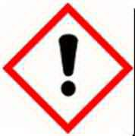Irritant

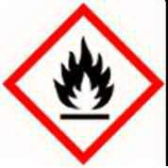Highly
Flammable

Chemicals and appearances:
Bluish - white or silvery grey solid in various forms - turns tarnished on exposure to air

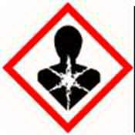Harmful

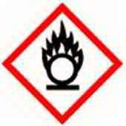Oxidising

Risk associated with use: | Lead can be absorbed through contact with the skin and eyes causing irritation
Personal Protection: | Wear gloves or gauntlets when handling lead, eye protection should be worn.  Do not eat , drink or smoke during work. Wash hands before eating
Storage: | Separate from food and feedstuffs and incompatible materials  (further information on MSDS)
Disposal: | Return any unused product to supplier, or plant depot.  Any material contaminated by the product should be designated as special waste, and disposed of through a specialist waste disposal contractor
Fire: | Not considered to be a fire hazard

Appointment Effect First Aid

Dermatitis, irritation, redness, pain
Skin
Wash well with plenty of soap and water for at least 15 minutes
Remove contaminated clothing. Seek medical advice. Wash clothing before re-use

Irritation, stinging Flush eyes with copious quantity of water.
Eyes
If irritation persists, seek medical advice

Irritation to nose and throat.
Inhalation
Coughing, drowsiness

Move to fresh air and rest. If symptoms persist seek medical advice

Swallowing Nausea, diarrhoea, vomitting Induce vomiting immediately as directed by medical personnel

