COSHH ASSESSMENT
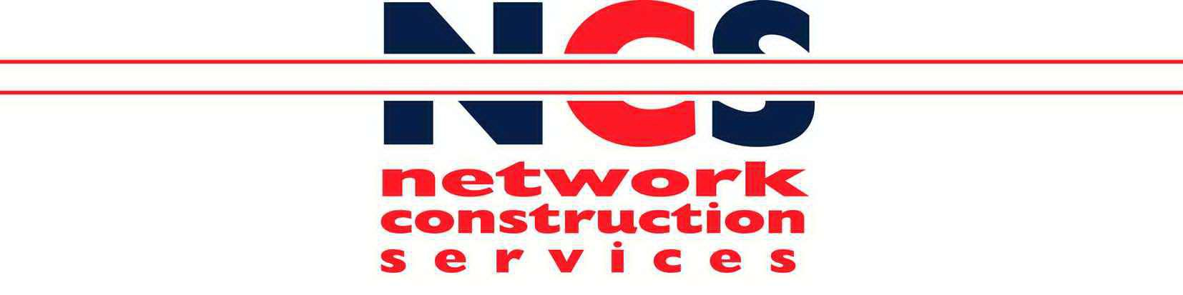NCS/FM/070 Issue005/Jul09

Ref: COSHH 05

Assessed by: Matt Traynor Position: Managing Director

Date: January 2022

Reviewed by: Matt Traynor
Position: Managing Director
Date: January 2022
008/Jan 2022

Trade name / Supplier: Telephone number:

Contact:

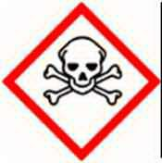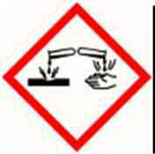Toxic Corrosive

Product type:

Petrol

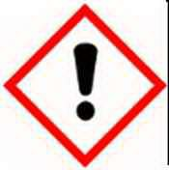Irritant

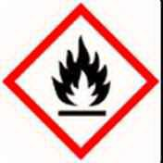Highly
Flammable

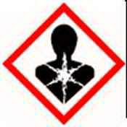Harmful

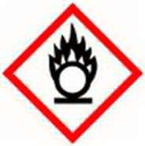Oxidising
Chemicals and appearances:
Clear liquid.
Strong odour.
Contains Polycyclic Aromatic Hydrocarbons

Risk associated with use: | Extremely flammable  Prolonged skin contact can lead to dermatitis and skin cancer
Personal Protection: | Wear impervious (rubber) gloves or gauntlets when handling products or containers  If exposure is prolonged or repeated, protective overalls and eye protection should be worn.
Storage: | Store and use from containers designed for use with this product.  Containers to be labeled and kept closed when not in use.  Store and dispense in well ventilated areas. No smoking, eating or drinking when handling product
Disposal: | Return any unused product to supplier, or plant depot.  Any material contaminated by the product should be designated as special waste, and disposed of through a specialist waste disposal contractor
Fire: | Powder, foam, halon or Carbon Dioxide extinguishers must be available at storage areas  DO NOT USE WATER  Empty containers represent a fire hazard, do not accumulate, return to supplier
Spillage: | Confine and absorb with inert material e.g. sand. Treat as a fire hazard.  If contamination of water course or drain occurs, contact site management immediately

Appointment Effect First Aid

Dermatitis, possible skin cancer
Skin
Wash well with plenty of soap and water.
Remove contaminated clothing. Seek medical advice if under pressure, or if injected under skin

Irritation, stinging Flush eyes with copious quantity of water.
Eyes
If irritation persists, seek medical advice

Irritation to nose and throat.
Inhalation
Coughing, drowsiness

Move to fresh air and rest. If symptoms persist seek medical advice

Nausea, diarrhoea, vomitting DO NOT INDUCE VOMITING.
Swallowing
Wash mouth out with water and seek medical advice

